Chapter 18, Problem 20.

(a) Show that a periodic signal with exponential Fourier series

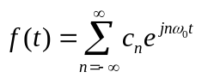

has the Fourier transform

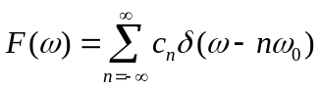

where ω₀ = 2π/T

(b) Find the Fourier transform of the signal in Fig. 18.37.

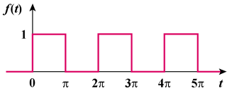

Figure 18.37
For Prob. 18.20.

